5.Crypt Arithmetic Problem
Aim
To solve a Crypt Arithmetic puzzle using AI.
Objective
To assign digits to letters such that arithmetic operations are satisfied.
Algorithm
- Assign unique digits to letters.
- Check arithmetic validity.
- Continue until a valid solution is found.
- Display solution.
Flowchart:
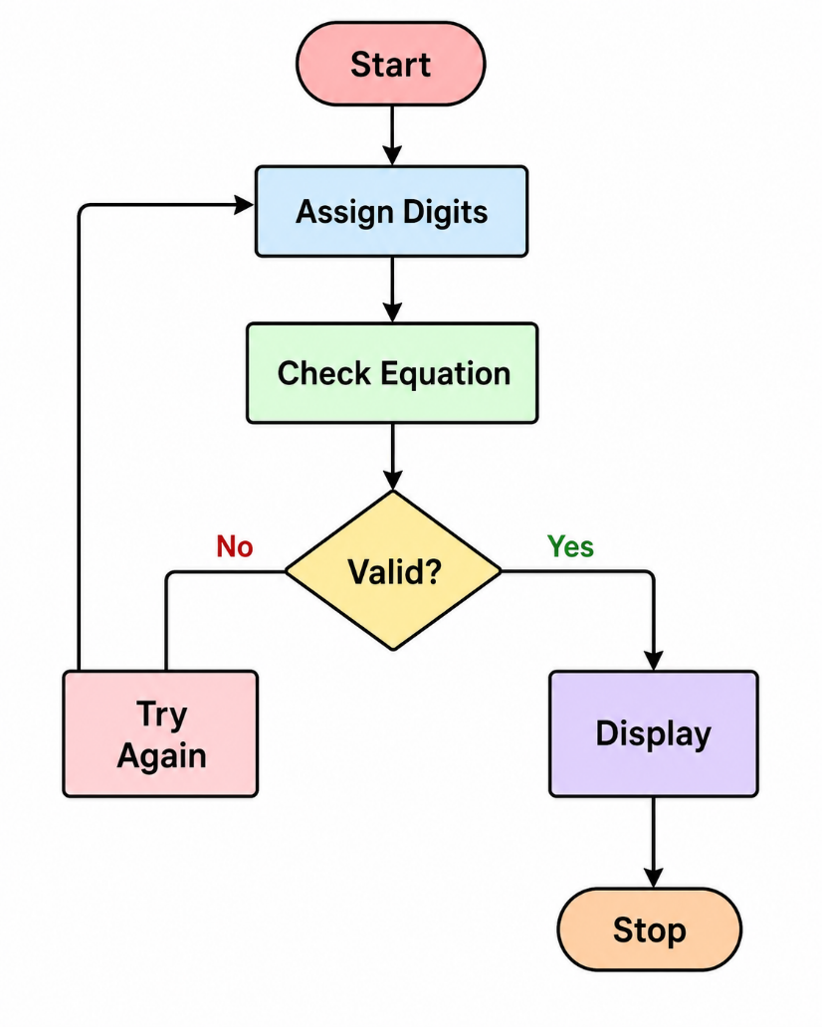

Python code:
from itertools import permutations

word1 = input("Enter first word: ").upper()
word2 = input("Enter second word: ").upper()
result = input("Enter result word: ").upper()

letters = ''.join(set(word1 + word2 + result))

if len(letters) > 10:
print("Too many unique letters (maximum 10 allowed).")
else:
digits = permutations('0123456789', len(letters))

for p in digits:
d = dict(zip(letters, p))

if d[word1[0]] == '0' or d[word2[0]] == '0' or d[result[0]] == '0':
continue

num1 = int(''.join(d[ch] for ch in word1))
num2 = int(''.join(d[ch] for ch in word2))
num3 = int(''.join(d[ch] for ch in result))

if num1 + num2 == num3:
print("\nSolution Found:")
print(num1, "+", num2, "=", num3)
print("Letter Mapping:", d)
break
else:
print("No solution found.")
output: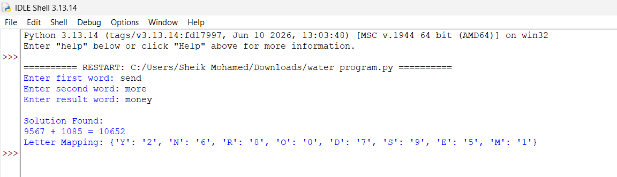
Result:
The puzzle was solved successfully.
Conclusion:
Crypt Arithmetic can be solved using constraint satisfaction techniques.

